[**https://besjournals.onlinelibrary.wiley.com/doi/full/10.1111/1365-2656.13406?campaign=woletoc**](https://besjournals.onlinelibrary.wiley.com/doi/full/10.1111/1365-2656.13406?campaign=woletoc)

**Understanding how snook respond to dynamic hydroscapes: Synchrony vs Individual Variation**

**Understanding how snook respond to dynamic hydroscapes: Synchrony vs. Individual variation**

**Space use switches: from heterogeneity to similarity in space use driven by environmental forcing**

**Does environmental forcing drive consistent similarities in space use in a riverine predator?**

**Environmental forcing drives similarity in space use in a riverine predator**

does environmental forcing cause spatial synchrony in the space use of a mobile estuarine consumer?

R.O. Santos1, R.E. Boucek2, J.A. Massie1, N.M. Viadero1,, PW Stevens3, J.S. Rehage1,

1Earth and Environment Department, Florida International University, Miami, FL 33199

2Bonefish and Tarpon Trust, Coral Gables, FL 33143

3 FWRI FWC , FL 33143

Corresponding author: R.O. Santos

Earth and Environment Department

Florida International University

11200 SW 8th Street, AHC5 364

Miami, FL 33199

[rsantosc@fiu.edu](mailto:rsantosc@fiu.edu)

**Journal guidelines**

<https://royalsocietypublishing.org/doi/full/10.1098/rsos.150266>

PRSL IF = 4.3

Journal of animal ecology = 4.368

Phil Tran RSL B = 6.139

Mov ecol 3.745

**Journal guidelines:**

continuous line numbering

upload figures as separate files

publication if free if under 6 printed pages (850 words = 1 page, 2-4 small figures = 1 page)

We require supporting data and information, including source code and other digital research materials, to be made available at the time of submission

see <https://royalsociety.org/journals/ethics-policies/data-sharing-mining/>

also cover the cost of submitting data to Dryad up to 20GB. Data submitted as electronic supplementary material will, upon acceptance of a manuscript, be deposited at the Royal Society's [figshare](https://rs.figshare.com/) portal free of charge.

The submitting author will be required to provide an Open Researcher and Contributor ID (ORCID) via the online submission system

**LTER submission data?**

**Abstract - 200 words**

**Keywords - 3-5 words**

**Episodic and long-term environmental changes are synchronizing the timing of sources of production in and nutrient cycling across ecosystems (Baines et al. 2000; Erlandsson et al. 2008; *Kominoski et al. 2020*).**

**8/10/20 Meeting Notes Jenn, Jordan, Nat, Rolo, Josh**

**Figure 1- Looks good**

**Figure 2- Looks good**

**Figure 3- Good**

|  | **River Zone** | | | | | | | | | | | |  |
| --- | --- | --- | --- | --- | --- | --- | --- | --- | --- | --- | --- | --- | --- |
| **Year** | **1** | **2** | **3** | **4** | **5** | **6** | **7** | **8** | **9** | **10** | **11** | **12** | **Total** |
| **2012** | **2** | **2** | **2** | **6** | **2** | **4** | **2** | **3** | **2** | **6** | **1** | **0** | **32** |
| **2013** | **3** | **2** | **2** | **6** | **3** | **4** | **2** | **3** | **3** | **7** | **0** | **5** | **40** |
| **2014** | **3** | **2** | **2** | **4** | **3** | **4** | **2** | **3** | **3** | **8** | **2** | **10** | **46** |
| **2015** | **3** | **2** | **2** | **3** | **1** | **3** | **1** | **3** | **2** | **6** | **2** | **10** | **38** |
| **2016** | **3** | **3** | **3** | **3** | **1** | **3** | **2** | **3** | **2** | **3** | **2** | **9** | **37** |
| **2017** | **3** | **3** | **3** | **3** | **3** | **3** | **2** | **3** | **2** | **3** | **2** | **7** | **37** |
| **2018** | **3** | **3** | **3** | **3** | **3** | **3** | **2** | **3** | **2** | **3** | **2** | **7** | **37** |

[**https://onlinelibrary.wiley.com/doi/abs/10.1111/oik.07509**](https://onlinelibrary.wiley.com/doi/abs/10.1111/oik.07509)

**Lab notes 6/11/20 -**

For snook paper:  
use kelble data

Use red drum - compare across zones

pulse recruitment with hurricane in fim data? 2017

other spp?

PCA regression - x axis as covariates

Fig 2- is a fitted line - need to improve the line of a?

2016-gam no solution-couldn’t fit correctly -

2017-poor estimates

Fish-have 70% similarity of the mean of habitat use

variance in hydrology last month

much higher area downstream - missing detections?

detectability may be higher upstream than elsewhere

2012-still signal of hydro

2016-no signal of hydro- cues of mov are gone

transient vs used habitat

aggregation

**To do:**

**a.Revisit PCA models for hydro:**

PC-do we need a seasonal model?

Suggestion make models to reflect: stage, stage at t and t-1, variance in stage, both

**b. jordan-**complete table with all yrs to see # of migrants per yr for all 7years & classify migrants as wet vs dry

**Still need to revisit and classify by wet/dry migrants**

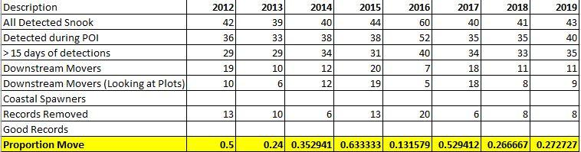

**Put in move months**

**Also, add dry period**

**c. Rolo**-re so the cluster analysis separately by season to see if clusters are changed

**Notes meeting 7/1/20**

Slide 15 -unique day zones

if you are moving across multiple zones on a day - what to do for those snook?

unique # of days per zone

----------------------------------------

total # of days of detection

And then averaged across all individuals for season that year

this excludes animals in transit

May need to know how many transit days there are vs unique zone days

unique days / detection days

unique combinations of dat

so for a fish detected in 2&3 in one day,

**Notes meeting 7/13/20**

when green wave is gone, animal space is more variable

2016

Fig are raw values but cluster analysis was done on Log +1

**Cluster A: least variable, 1,2, 3, 5, 8, 9, 11,**

**Cluster B: 6, trend for increase in wet**

**Cluster C: 4, 7 increase in wet**

**Cluster D: 12 higher use in dry**

**Cluster E: 10 highest use in wet**

**To do from 7/13/20 meeting**

Jordan is going to shade the zone map with clusters

Rolo will change colors to match colors of clusters

Rolo will revisit PCA model selection part

Nat-extend hydro record & do z scores by season plots

Jordan-look over the system & tagging method - add range in size, tagging

need a table with date tagged, zone tagged & mean size

Jordan-make table to accompany abacus

Rolo pass at intro

Rolo-stats results

Jenn drop key results from PP for section

Discussion: everyone add thoughts bullets & ideas

Jenn ideas for structure of discussion

Ryan- add Allgeier paper

Josh-look at individual variation in mov paper & add to a google folder & animals tracking production

**Notes meeting 8/10/2020**

**Introduction**

van moorten et al. 2015 JAE mov is the glue

Cote et al 2018 synchrony paper

Morales & Ellner 2002 ecol

mueller and fagan 2008 Oikos

Check out papers from stuck in motion JAE special issue 2016

Villegas Rios et al 2018 JAE

Jarillo et al 2018 Oikos pop synchrony

Walter et al 2017 EcolLett

Jonsen et al 2019 Ecol seal mov & env variation

Morales JM, Fortin D, Frair J, Merrill E (2005) Adaptive models for large herbivore

movements in heterogeneous landscapes. Landsc Ecol 20:301–316

Harrison et al 2019 for seasons variation in mov distances

Bestion et al 2015 Ecol Lett

The importance of individual variation in the dynamics of animal collective movements

Delgado et al <https://doi.org/10.1098/rstb.2017.0008>

A mechanistic theory of personality‐dependent movement behaviour based on dynamic energy budgets Campos‐Candela et al Ecol Lett

heterogenous vs homogenous space use

Lele, S.R., Merrill, E.H., Keim, J. & Boyce, M.S. (2013) Selection, use,

choice and occupancy: clarifying concepts in resource selection studies.

Journal of Animal Ecology, 82, 1183–1191.

Allgeier, J. E., T. J. Cline, T. E. Walsworth, G. Wathen, C. A. Layman, and D. E. Schindler. 2020. Individual behavior drives ecosystem function and the impacts of harvest. Science Advances 6:eaax8329.

**VanMoorter 2013 JAE**

movements are the primary behavioural adaptation to dynamic resource landscapes (McPeek & Holt 1992; Mueller & Fagan 2008),

the ultimate function of all types of movements is to increase individual fitness

through an optimal exploitation of resources, which vary in space and time: 3 predictions

* more frequent daily mov with increasing fine scale forage depletion/regrowth patterns
* predict increased distance moved with increasing spatial scale of change
* animals experiencing large waives of change in spring, migrate longer distances (as opposed to synchronized env

Van Moorter 2013 JAE individual diff in scales of mov are largely explained by spatial differences in scales of env change (short-distance mov are performed by individuals inhabiting regions that experience little spatial variation in yearly phenology, whereas as long distance move are performed by individuals experiencing marked spatial variation in annual penology. See Mueller et al 2011 Glob ecol & biogeo for more on this

**Mueller et al 2011 Glob Ecol & Biogeo**

need to examine the relationship that exists among moving individuals to get to emergent spatial dynamics at population level

interrelationships among

**Static landscapes or dynamics at small scales should favour sedentary ranges, dynamics that vary across broad scales but are predictable should facilitate migration, and broad-scale dynamics that are less predictable should support nomadism (**

Moose, which remained in sedentary home ranges, and guanacos, which

were partially migratory, exhibited relatively short annual movements associated

with landscapes having very little broad-scale variability in vegetation. Caribou and

gazelle performed extreme long-distance movements that were associated with

broad-scale variability in vegetation productivity during the peak of the growing

season. Caribou exhibited regular seasonal migration in which individuals were

clustered for most of the year and exhibited coordinated movements. In contrast,

gazelle were nomadic, as individuals were independently distributed and moved in

an uncoordinated manner that relates to the comparatively unpredictable (yet

broad-scale) vegetation dynamics of their landscape.

broad-scale landscape unpredictability may lead to nomadism

long-distance movements of nomadic individuals are uncoordinated and

independent from other such individual

Landscapes with little broad-scale variability

in vegetation productivity feature smaller-scale movements and allow for

range residency. Nomadism requires distinct integrative conservation strategies

that facilitate long-distance movements across the entire landscape and are not

limited to certain migration corridors.

Morales & Ellner 2002 ecol

mueller and fagan 2008 Oikos

Morales, J.M. & Ellner, S.P. (2002) Scaling up animal movements in heterogeneous

landscapes: the importance of behavior. Ecology, 83, 2240– 2247.

**Van Moorter et al 2016 JAE mov is the glue**

geographic (individual home range & spatial distribution, Moorcroft 2012J of Mammal, Moorcroft & Lewis 2006Home range book, Van moorter et al 2009Oikos) vs env space use(identify factors determining resource/habitat use & selection, Manly et al 2002, Moorcroft & Barnett 2008Ecol, bastille-Rousseau et al. 2010 ), but all patterns of space use emerge from ibdd mov and the mov responses of individuals to env heterog

Mov = primary way org change their env is glue linking home range to habitat selection

2 focal mov properties shape geographic & env spac euse

residence time=RT - higher residence time means lower speed & more tortous mov

time to return =TtoR -more direct mov towards high qual habitat

RT should increase and TtoR should decrease in high quality resoruce areas

Predictions:

High variation in RT and TtoR among habitats leads to strong habitat selection

long RT and short TtoR results in small home range size (same for increased spatial autocorrelation in RT)

short RT and long TtoR results in large home range size

animals decision to move is a response to change in the env space to satisfy requirements (e.g., refuge, resources)

animals move to change env conditions associated with changes in locations

mov occur in respons eto env conditions experienced by animal

The env affects the animals mov & these in turn determine its space use

mov allow animals to seek, access & exploit resources

The decisions about departure are based on observed or anticipated local environmental

conditions (e.g. resource depletion), whereas decisions about visiting a new location are based on expected environmental conditions through perception or memory.

Moorcraft & Lewis (2006) increased diffussion & decreased advection lead to increased home range size

Bastille-Rousseau et al 2012 Selective use results from increased RT or nicreased revisitation

smaller home ranges in more favorable habitats

conceptual framework

space use pattern is a function of :

Home range size in geographic space

Selection of the home range in the landscape

Selection of patches or resources within home range (sensu Johnson 1980) in the env space

if resources are unpredictable, return is not an efficient tactic & animals are epxected to increase only RT

Individual variation paper for SRS

net displacement - does it vary across ind within and across seasons?

straight line distance between 2 locatiosn separated by a given time interval, 1 day, 16 mon

Max displacement between seasons MD(delta T is = 6 months)

assume that ind respond to env conditions within their ranges -

then relate env variables within center of their locations (average circular 16 day range

moving average of 16 day displacement - scale of resolution of env data

animals move to exploit resources varying in sapce and time

escapes-

temp can be used as cost

mov responses of ind to env heterogeneity

animals decision to move is a response to change in the env space to satisfy requirements (e.g., refuge, resources)

animals move to change env conditions associated with changes in locations

mov occur in respons eto env conditions experienced by animal

The env affects the animals mov & these in turn determine its space use

mov allow animals to seek, access & exploit resources

**P1: Animals track env heterogeneity with mov**

A primary way in which animals respond to environmental heterogeneity is with their movements (McPeek and Holt 1992AmNat; ref, mueller and Fagan 2008). Animals move through heterogeneous landscapes at varying scales to increase individual fitness while tracking resources, suitable or preferred abiotic conditions, mates and conspecifics, and avoiding predators, competitors and pathogens (Nathan et al. 2008, Clobert et al 2009). Further, these conditions are variable in time, which strongly influences the movement strategies of mobile organisms (e.g., the frequency and length of animal movements, Van Moorter et al. 2013). the coupling of high resolution movement data with environmental data and biologging allows us to greatly improve our understanding of both the external and internal drivers of animal movement (Nathan et al 2008, King et al 2018TREE). dynamic resource and ecological landscapes

For instance, by coupling movement data with NGVI...xxxxx green wave example.

During spring, landscape-scale waives of vegetation greening in temperate regions, consumers track these spatial changes in resources - ungulates

For consumers that track spatial variation in resource phenology (e.g., they surf resource waves, Armstrong et al. 2016Ecol), HRMD can inform on how consumers shift space use over seasons as they track resources or across years of varying phenology, altering how they translocate nutrients and link food webs spatially.

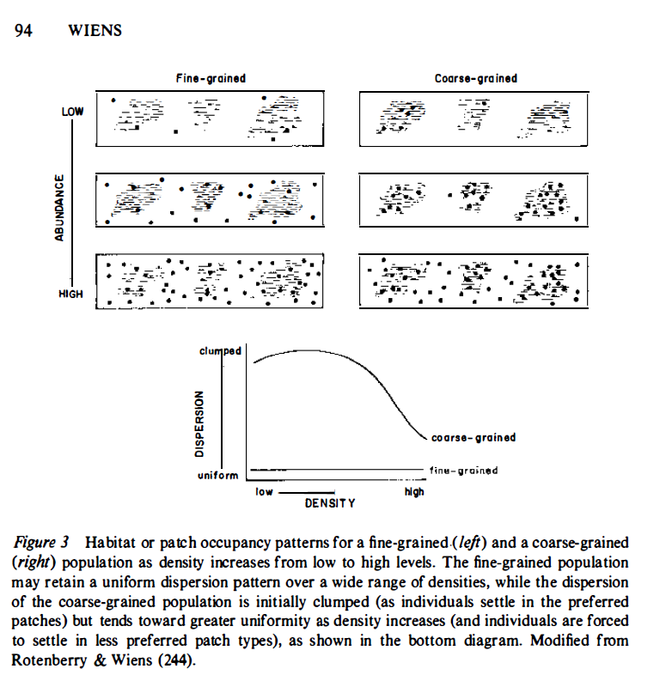

*External aspects that may affect the focal individual’s movement, either directly or through an interaction with its personality include aspects of its social environment (e.g. local density and group composition; Farine et al. 2015) and its ecological environment (e.g. threats, resources, landscape structure; Barton & Hovestadt 2013; Bonnot et al. 2015).*

**P2: tracking data shows lots of ind variation**

A key insight from high-resolution tracking studies is the prevalence of intraspecific variation in movement (Harrison et al. 2015, ). Individual variation in movement can be significant, accounting for a large proportion of variation in movement traits (>30%), and matching or exceeding levels of interspecific variation (Stevens et al.2010PlosOne, Villegas-Rios et al. 2017AniBeh, Harrison et al 2019BehEcol). In fact responses by organisms to environmental heterogeneity hve been shown to be modulated by individual variation, particularly as a result of consistent differences in behavioral traits or personality (Sih et al. 2004).

renewed appreciation for extent & comm consequences of intraspecific variation ignoring this variation underestimates teh ability of species to endure presence of others, misrepresents fraction of resources that the population uses and underestimates degree of niche and trait overlap between species distribution of trait values

Intraspecific variation in move can be generated by variation in traits: morphological, LH, physiological and behavioral, things like boldness aggression or sociability

trait variation can generate variation in demographic rates parameters, interaction strengths , niche breath ecological attributes

Spiegel, O., Leu, S.T., Sih, A., Godfrey, S.S. & Bull, C.M. (2015b). When the going gets tough: behavioural type-dependent space use in the sleepy lizard changes as the season dries. Proc. R. Soc. B Biol. Sci., 282, 20151768.

Villegas Rios et al 2018 JAE

Harrison et al. (2015) showed that individual wild Burbot (Lota lota) differ consistently in several interrelated measures of space-use (home range size,

site fidelity and movement distances).

we only considered personality differences in the mean response to an environmental gradient (reactionnorm intercepts), whereas actual personalities often also differ

in their responsiveness to the gradient (i.e. the slope; Dingemanse et al. 2010).Differential responsiveness may have a polarising effect, with stronger differences among personalities

in some environments than in others

***From spiegel et al. 2017***

*it is often hard to discriminate between the contributions of environmental heterogeneity and behavioural differences among conspecifics (Hawkes 2009).*

*Personalities interact with environmental condition to affect these phases across a wide range of organisms (Fogarty et al. 2011; Chapple et al. 2012; Sih et al. 2012; Larranaga et al. 2013; Duckworth et al. 2015; Wey et al. 2015). For instance asocial lizards were more likely to leave populations with high densities and tended to settle in low-density populations (Cote & Clobert* 2007).

T*hird, different personalities may consistently differ in the external*

*factors they experience and respond to or simply in the environments they inhabit (Wilson & McLaughlin 2007; Kurvers et al. 2010; Kobler et al. 2011; Pearish et al. 2013).*

*when quantifying movement specializations of free-ranging animals, it is often hard to distinguish between genuine behavioural differences among individuals and those arising from spatial variation in habitat features they experience (e.g. resources, refuges) (Dingemanse et al. 2010. For instance individuals living in dangerous areas may appear less active than those living in safer areas regardless of their innate tendencies. It is important to contrast behaviour in the same conditions or range of conditions to compare behavioural reaction norms where the y-axis is an index of movement behaviour and the x-axis is a relevant habitat gradient (Dingemanse et al. 2010).*

***From DesRoches 2018***

*intraspecific variation increase demographic resilience and evolutionary potential in populations, our analysis shows that it may also structure communities and shape ecosystems 19,22 Human activity is drastically altering variation within species by driving rapid trait*

*change and extirpation of wild populations 20,33. Our results suggest that such rapid and pervasive changes to intraspecific diversity are likely to have important consequences*

*for the future of communities and ecosystems.*

*While individual variation is beginning to be recognized in conservation and management policy (Killen et al. 2016; Ward et al. 2016), spatial management policy largely continues to be guided by mean species-level estimates of dispersal and movement (Holyoak et al. 2008).*

**P3: But env heterogeneity can also synchronize individuals**

While intraspecific variation is widespread in ecological data sets, studies have shown that environmental factors can act to synchronize ecological processes animal movement and space use.

Deacy et al. 2017 PNAS climate change induces synchrony in foraging opportunities that would otherwise occur sequentially resources resulting prey where these phenological shifts are disrupting ecological links with major implications for terrestrial ecosystems (salmo fertilization of forests, Deacy et al. 2017 PNAS

Wang, G. et al. Spatial and temporal variability modify density dependence in populations of large herbivores. Ecology 87, 95–102

(2006).

# Theme issue ‘Collective movement ecology’ compiled and edited by Andrew M. Berdahl, Dora Biro, Peter A.H. Westley and Colin J. Torney

homogeneous space use is driven by pulses of prey - clustering of individual

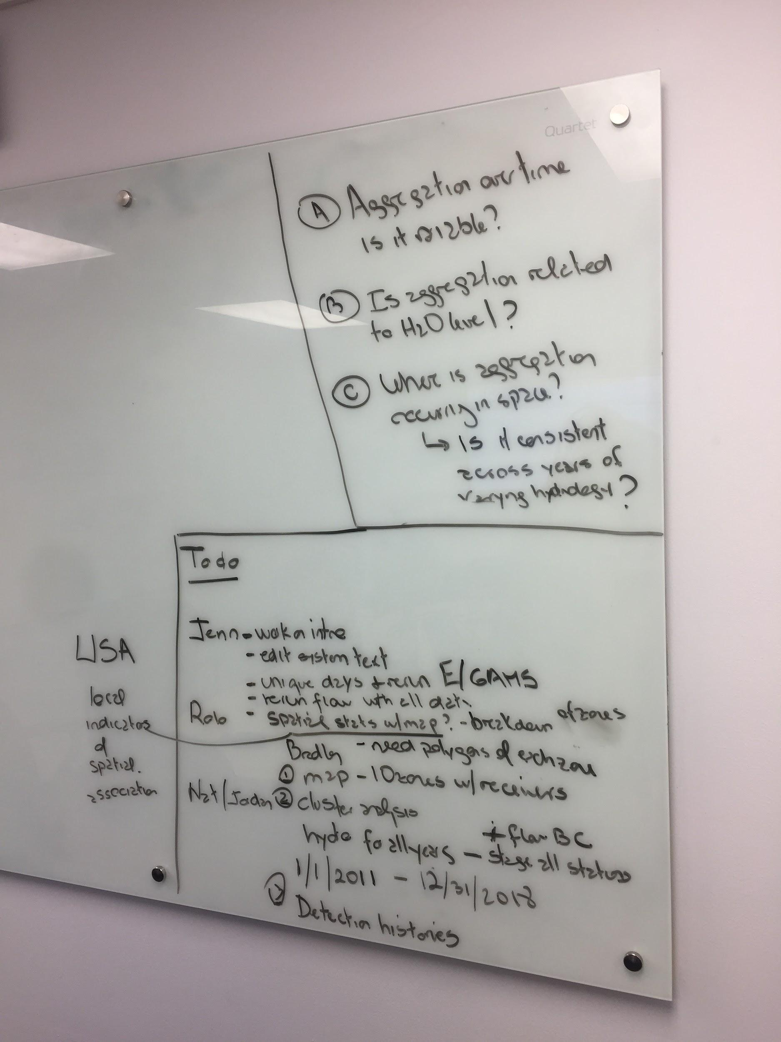

**How does pattern of space use vary over time? How does this variation relate to env drivers What causes similarity/dissimilarity in space use that may be telling of aggregation to disaggregation of of individuals in space**

**Metrics are more about proportionate space use - preference, interspecifc var in space use in terms of niche/diet**

**P4: In this study….**

In this study, we examined the tension between intraspecific variation in space use and environmental variation which acts to drive similarity in space use across individuals. **Our study asked the following questions: 1) does environmental forcing cause increased similarity in the space use of a mobile estuarine consumer, 2) what drives this spatial similarity? and 3) where is spatial similarity occurring in space? and 4) and how variable is this space use similarity over time and space?** We focused on how temporal variation in environmental conditions drove consumer space use along a continuum from asynchrony (or high interspecific heterogeneity) to synchrony. Specifically, we used acoustic telemetry to examine the space use of Common Snook (*Centropomis undecimalis*) along a riverine scape and in response to seasonal variation in water levels. We hypothesize that seasonal hydrologic variation would cause snook to switch between synchronous and asynchronous space use. We expected high asynchrony in space use during the wet season at high water levels, with fish broadley distributed across the riverscape. In contrast during the dry season, we predicted snook to aggregate at the upper reach of the river where prey are known to pulse as surrounding floodplains dry (Boucek et al. 2013, Boucek et al. 2016), resulting in a high level of spatial synchrony.

**P5: system and system- specific hypotheses**

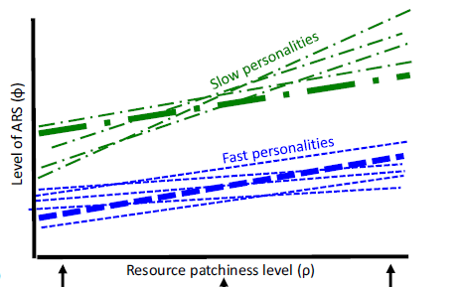

consider reaction norm approach (Dngemanse et al. 2010

The behavioural reaction norm (Dingemanse et al. 2010) is

a useful framework for studying animal responses (y-axis) to

their environments (x-axis, typically centred around zero; see,

e.g. Fig. 2a). Personalities can differ in their behaviour both

in a given environment (different reaction-norm intercepts)

and/or in how much they change their behaviour along an

environmental gradient (different slopes; i.e. their plasticity).

this reaction-norm approach can be

applied to relate interindividual differences in movement (the

dependent variable) to environmental gradients in the habitat

(the independent variable).

could our y axis be the mean distance of space use over the season (distance upstream, and we could code it by season -centroid distance - coded by year? of different panels for different years?

Caribou exhibited regular seasonal migration in which individuals were

clustered for most of the year and exhibited coordinated movements.

**Materials and Methods**

**Shark River** (Inserted from Snook ESCO manuscript as template)

Using acoustic telemetry, we tracked the movements of adult snook in the Shark River (SR), an extensive coastal river system in the southwestern region of ENP, Florida, USA (Fig. 1). The SR is the main conduit of water through the western portion of the Everglades, with hydrology driven by rainfall and tidal cycles (McIvor et al. 1994; Saha et al. 2012). The SR spans about 32 km with a drainage area of roughly 1,700 km2, and is composed of graminoid marshes with oligohaline creeks in the upper reaches that transition into mangrove forests, a shallow (1-2 m) open water area ,Tarpon Bay, at the midpoint, and progressively larger and more saline channels flowing throughout the estuary and into the Gulf of Mexico (McIvor et al. 1994; Fry and Smith 2002; Saha et al. 2012). Although affected by human induced changes and drainage, the characteristic wet/dry seasonal pattern has been retained, with about 80% of the system’s rainfall occurring between July and November (Marshall et al. 2014; McIvor et al. 1994; Price et al. 2008; Saha et al. 2012).

**Common Snook** (Inserted from Snook ESCO manuscript as template)

Snook are a tropical euryhaline species found in freshwater river systems and marine habitats throughout the Caribbean, with Florida populations occurring at the northern extent of their geographic distribution (Blewett et al. 2009; Muller et al. 2015). These fish are highly targeted by anglers in the Everglades, in a largely catch-and-release fishery (> 95% of snook caught are released) that makes substantial contributions to the economy (Muller et al. 2015). About 2.5 million snook are caught in Florida each year, and the species is the fourth most targeted by anglers on the southern Atlantic coast, and third most targeted in the Gulf of Mexico (Muller et al. 2015). Reproducing adults use estuaries and marine areas to spawn, with juveniles subsequently moving upstream into nursery habitats in small creeks and freshwater marshes (Gilmore et al. 1983; Peters et al. 1998). At about two to three years old, snook enter the fishery as they leave these backwater rearing areas and move into estuaries and larger riverine channels (Taylor et al. 1998).

Adult snook use different habitats in the SR throughout the year, and seasonal movements across river zones are predominantly associated with spawning, and upper river prey availability (Boucek and Rehage 2013; Boucek et al. 2017; Stevens et al. 2018). Downstream movements are mostly attributed to reproduction, and are highest during May through August, with peak spawning activity occurring in June and July (Lowerre-Barbieri et al. 2014; Boucek et al. 2017; Matich et al. 2017; Boucek et al. 2019). Upstream movements correspond to falling water levels during the dry season (January–June), as snook move into the upper river tracking abundant prey sources that are concentrated in river channels by drying marshes (Boucek and Rehage 2013; Matich and Heithaus 2014; Blewett et al. 2017; Boucek et al. 2017; Matich et al. 2017). Not all fish make these annual migrations, and research in south Florida has indicated that > 40% of fish may express skip-spawning behavior and remain in the upper river year-round (Trotter et al. 2012; Lowerre-Barbieri et al. 2014; Young et al. 2014, Boucek et al. 2019). Past telemetry studies in the SR have indicated that snook are most frequently detected in the upper river (85% of detections, Matich et al. 2017).

**Shark River acoustic array** (Inserted from ESCO Snook manuscript as template)

Receiver Map (See Insert at end of Document, can be easily edited to match context of manuscript), Count (37 Receivers), Zones, Downstream/Bay/Upstream

The SR can be divided into three ecologically distinct zones with varying habitat characteristics (Fig. 1b); the oligohaline upper river, the mesohaline central embayment (Tarpon Bay), and the deeper, larger, predominantly polyhaline lower river (Rosenblatt and Heithaus 2011; Boucek et al. 2017; Matich et al. 2017). The upper river (river km > 23) consists of narrow channels (2–50 m) bordered by a combination of mangrove and freshwater marshes containing a mix of sawgrass (Cladium sp.) and freshwater woody plant species, with depths ranging from 1–3 meters, rocky/mud bottoms, and limited tidal influence (Chen and Twilley 1999; Childers 2006; Boucek and Rehage 2013; Boucek and Rehage 2014). Tarpon Bay (river km 15–23) is marked by a transition from a predominantly freshwater fish community to one primarily consisting of estuarine species, with shallow (generally < 2 m) open (200–500 m across) habitats, and soft muddy bottoms with low submerged aquatic vegetation (Rehage and Loftus 2007; Rosenblatt and Heithaus 2011; Boucek and Rehage 2013). The lower river (river km < 15) is characterized by deeper (3–5 m) and wide riverine channels (about 100 m or greater) and is the most marine-influenced, although salinity fluctuates between the wet and dry seasons and can range from about 10–35 PSU (Childers et al. 2006). Red Mangrove (Rhizophora mangle) shorelines are present in all three zones; however, height and biomass increases toward the more productive, lower sections of the river (Chen and Twilley 1999; Childers 2006; Ewe et al. 2006).

**Tagging** (Inserted from ESCO Snook manuscript as template)

Acoustic monitoring of tagged adult snook began in 2012, with ongoing tagging efforts continuing through 2019. Fish are captured using boat-based electrofishing along shorelines in Tarpon Bay and the upper river zone (detailed in Boucek and Rehage 2013). When snook are caught, they are placed in a livewell, and transferred to an onboard tagging station within 2–3 minutes of capture. Following standardized methods (Adams et al. 2009; Trotter et al. 2012; Lowerre-Barbieri et al. 2014; Boucek et al. 2017), tagging consists of a minor surgical procedure, where a 30-mm incision is cut in the lower abdomen, and an acoustic transmitter (69kHz V13 or V16, Vemco, Halifax, NS, Canada) is implanted into the abdominal cavity. Incisions are closed with one to two sutures, and fish are held in water alongside the boat and allowed to regain full equilibrium before release. The mean interpulse delay for the transmitters is 120 seconds, resulting in a battery life of about 36 months, and previous studies have estimated that the post-release survival of snook is about 85% (Boucek et al. 2019

Need to add: timeframe, sample size

Here is the unique transmitter IDs I am using in the sync paper. As I mentioned before, these are the transmitters with >= detection range of 90 days and more than 100 detections.

**Data processing**

* + 1. Selection of individuals
       1. >90 days
    2. Time variables
       1. Year
          1. Disturbance presence
       2. Season: Dry vs Wet

**Data Analysis (Rolo)**

* + 1. E-index
       1. Measure of intraspecific use of resources
       2. Proxy of synchrony and intraspecific use of space
    2. Statistics
       1. Intraspecific movement
          1. E-index difference between Years and Season
          2. E-index relationship with environment
       2. Movement strategies
          1. Cluster and PCO analysis

**Results**

*Individual variation in space use over time*

We observed strong seasonality in how Snook used the riverscape, particularly in the level of individual variation across the 12 river zones. Snook had similar space use in the wet season, but individual variation increased in the dry season. Monthly E’s cycled over the seven years of Snook tracking, with generally higher levels in the wet season, indicating heterogeneity in space use, and lower values in the dry season, indicating higher similarity in space use (Fig. 3A). Across years, E differed between wet and dry season months in five of the seven years (Fig. 3B). Smoothers fitted to years explained 44 % of the variance in E, and indicated significant nonlinear patterns for 5 of the 7 years (Table 1). The exceptions were 2012 and 2016-years that followed droughts in 2011 and 2015 respectively (Appendix 3). Further, 2016 was an el Nino year, with extremely high water levels in the dry season, which prevented upstream marshes from approaching zero or fully drying, as observed across the other six years in the timeseries.

Cycle of E

Figure 2b

Dry vs Wet (plus stats)

Figure 2c

Dry vs Wet by Year (plus stats)

*Variation in E as a function of hydrological conditions*

We found evidence that the level of individual variation was affected by river stage, particularly in the dry season. Stage variables explained 44% of the variation in monthly Es (Table 2). The space use of Snook became more variable across tagged individuals as water levels increased (Fig. 3a). We detected a positive relationship between E and the mean stage index in both wet and dry seasons, but the effect was stronger and more linear in the dry season (as shown by the lower p-value and lower edf, Table 2). In the wet season, the effect on E leveled off at high water levels. This mean stage index reflected stage across the entire river, since the index is PC1 in the principal component analysis of the hydrological data (Appendix 4). Variables strongly correlated with PC1 included mean stage at all four hydrological stations along the Shark River for both the current month and month-1. Model selection showed that the best model was the one that included PC1 and PC3, together these components explained XX% of the variation. For PC3, variables strongly correlated with this principal component included standard deviations of stage at all four hydrological stations at month-1.Monthly E’s showed a nonlinear relationship to this lagged stage variance in the dry season (Fig. 3b); with highest levels of space use variation at intermediate levels of stage variation. We saw no relationship for the wet season.

*Differential space use of river zones*

Contrary to expectations, we observed a high level of variation in the pattern of seasonal use of river zones. Zones that showed either an increase or a decrease in use between the wet and dry seasons varied across years, with a general pattern of greater differences in more recent years (Fig. 4). Across zones, zones 1 and 2 showed relatively little seasonal change across all seven years, since these were the most consistently used areas by Snook (Appendix 5). The cluster analysis showed two significantly different clusters for the factor year, one for year 2016, the El Nino year with the extremely wet dry season (Appendix 3), and a second cluster that included the other six years (Fig. 5a, Appendix 6). In 2016, space use was more variable across seasons than in all other years, particularly in the mid and lower parts of the river. For instance, we saw pronounced increases in the use of zones 4, 7 and 12 in the dry season in the 2016 El Nino year that were not observed in other years (Fig. 5). Across zones, the cluster analysis showed an optimal solution of 5 clusters, but relative change did not vary significantly among them (p = 0.169; Appendix 6). Zones at the headwaters of the river, central Tarpon Bay and the northern exit to the Gulf of Mexico (Cluster A) showed little seasonal variation in space use (Fig. 5). In contrast, zones surrounding Tarpon Bay (clusters B, C & E) showed an overall increase in space use in the wet season, while the southern exit to the Gulf of Mexico (Cluster D) was the most seasonal variation with a tendency for an increase in use by Snook in the dry season.

**Discussion**

**P1. Summary**

**key take homes from data**

**1) does disturbance disrupt space use ? does environmental forcing alter similarity in space use? is the pattern of space (similar or heterogeneous) affected by disturbance**

Yes, E cycles within year - similarity is space use increases in dry season relative to wet season

But cycle is disrupted years with high disturbance or that follow a disturbance, hurricane, 2 post drought/high water -

Fig 2 a/b cycles and breakdown of cycle by year, table with model output

**2) what drives this spatial similarity?**

Variation in E is driven by stage - mostly by mean and not that much by variability is weaker, only place that matters is upstream. Mean drivers a response in dry season, mostly upstream

range of variation is constrained. More similar space at lowest stages of the dry season - dry season affects space use more. Highest effect is upstream and in dry season stage

variability has a weak effect upstream only

Fig 3 a mean/b variance

**3) where is spatial similarity occuring in space? and**

most space use is upstream and the space use because more pronounced in dry season

rate of change between wet and dry varies

**4) and how variable is this space use similarity over time and space?**

space use is consistent (hotspot of use) but seasonality changes between years. some yrs have stronger use upstream

**P2. Limitations**

* + 1. Limits of telemetry vs more continuous observations (gps, manual tracks, etc)
    2. Spatial resolution of tagging effort
    3. But…

**P3 How this compares to previous work examining env factors vs ind variation - imp of heterogeneity in space use**

**Deacy et al. 2018 Sci Reports: i**nterannual variation in salmon abundance likely has less effect on salmon consumption than individual variation in bear foraging behavior**.**

**Ruff, C. P. et al. Temperature-associated population diversity in salmon confers benefits to mobile consumers. Ecology 92, 2073–84**

**P4 Mechanism for this variation is prey tracking**

over time ( of foraging opportunity, and thus surf resource waves (e.g., consumer riding resource waves surfin gof green wave by ungulates,

consumers track shifting mosaic of foraging opportunity (surf the wave

which protract foraging oppoutuing, consumers sequentially explint multiple pre populations

For many species, resource landscapes and their temporal distribution plays a majore how these vary temporally will play a major sesare a major determinant of animal Movements and migratory route

that a migratory ungulate surfs the green wave and in so doing, extends the amount of time exposed to high-quality forage.

**P5 howe we think this relates to personality**

*From spiegel 2017*

*slow individuals may be better at exploiting predictable*

*resources, whereas Fast individuals may perform better*

*with less predictable resources. Similarly, temporal*

*variation (e.g. seasonal changes in resource distribution) may favour different personalities at different times, facilitating coexistence*

*of multiple personalities. If individuals can select the habitat where they*

*are most efficient (a true preference), or if they simply survive*

*better in these habitats due to greater foraging success, then*

*their differential movements may lead to an apparent personally*

*dependent habitat preference.*

*Fast explorers are*

*often also less sociable, more aggressive and bolder in novel*

*environments (Sih et al. 2004)*

*Numerous studies (e.g. Wilson & McLaughlin 2007; Kurvers et al. 2010; Reale et al. 2010; van Overveld & Matthysen 2013; Patrick & Weimerskirch 2014)*

*have documented both ‘Slow’ and ‘Fast’ explorers (usually, a*

*continuous range, but often compared as if dichotomous).*

*Slow explorers are more cautious and methodical in their*

*search, but more sensitive to environmental variation. Fast*

*explorers tend to be bolder, more aggressive, move more*

*rapidly, but without paying as much attention to environmental*

*stimuli and change.*

For instance van Overveld & Matthysen (2010, 2013) used

experimental feeders to challenge great tits (Parus major)

with an abrupt change in food supply, and found that Fast

exploring individuals switched more rapidly to different foraging

areas at longer distances from the feeder and resampled

empty feeders at a lower rate.

**P5 Implication to populations**

* + 1. Vulnerability to stressors
    2. Buffer effects
    3. Management implications

**P5 implication of temporal change in mov for food webs**

The importance of the greenscape highlights the value of incorporating both the spatial

structure of resources and the temporal dynamics of resources into the definition and quantification of habitat

(Armstrong et al. 2016)

McMeans temporal forcing

Rewiring of food webs

**P6. In summary**

Significance of results

* + 1. Response to environmental heterogeneity is temporal dynamic
    2. Other/similar examples

Figure legends

Acknowledgements

Funding

***This work was supported by***

References

**8/6/19 Notes**

Come up with language - heterogeneity of space use

proportionally equal space use

intraspecific variation in space

**Notes 7/15/2019**

variation in E across the season

Distribution of e values across months with year as a factor

e value per month vs monthly stage value

To do:

Dig up E relations to hydrology

dynamic factor analysis: brodgar

# Link the clustering of mov strategizes better to synchrony (using E) or we drop it and and we expand

what are hot spots of space use in wet and dry

make E analysis more spatial -

where in the river do we expect a consistent hot spot of space use

Rerun analysis with hydrology up to 2018

update with 2018

# clustering of the E value across time?

Stage 2011-dec 2018 daily mean stage

Bottle creek - upstream

CN upper ⅓

TE mid

GI downstream

How disturbance influence space use and cause aggregration

relate the E to pulses

reflection of pulse in next year’s fitness -

What are implications?

at population level: metric of fitness, spawning

#### [Collective movement in ecology: from emerging technologies to conservation and management](http://rstb.royalsocietypublishing.org/content/373/1746/20170004)

E - how does it change

Is E concentration in same space  
 where is disagregation happening

How does E change with stage

Notes from meeting 9/6/2019

Table 1: 2012 not sig, 2015 not sig

smaller p value is better because of the estimate 0.00465

Cycling of habitat use is disrupted post-disturbance

all dry for mean stage and downstream wet

e= 1 - highest separation

e = 0 eating same thing

relatvie % change, standardized within year

formula = w-d/dry

z score - within the year

To do:

1. PCA of 4 stages and run E index mean and variance against PCA -

A = 2016 low

B = variable - 2014/2013

C, higher, 2017, 2015, 2018, 2012

A - 0 or neg value, no change or decrease from dry to wet

c - zone buy

should we standardized globally?

proportion of days

for each individual per season per year, zones a s columns - how many unique days are you detected in each zone/year and then broke it - per individual and then average across

each day is unique

length of unique days

if you moved, both get counted, per combination ID*zone*season* yr